

VIF: high vif means this feature explained by other variable very nicely so we can neglect

D

eployment using ec2:

Model build

Pickle : model

Building flask- api creation

Ec2 login

Ubuntu server

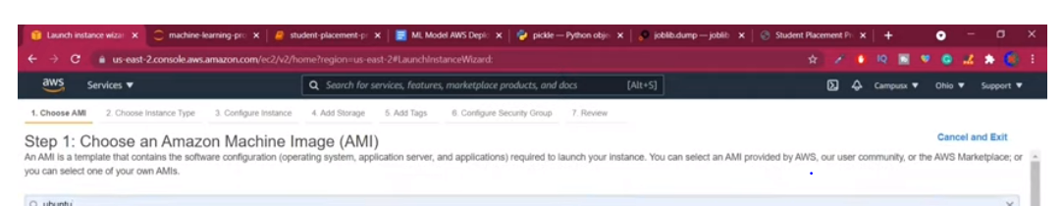

Choose instancetype t2

Nano,large

Xlarge

Configureinstance,

Storage

Agg Tags:

Name :ec4

Configure security group

Who has to interact with ec2 – which dependencies can interact like mysql,ssh –

Review and launch

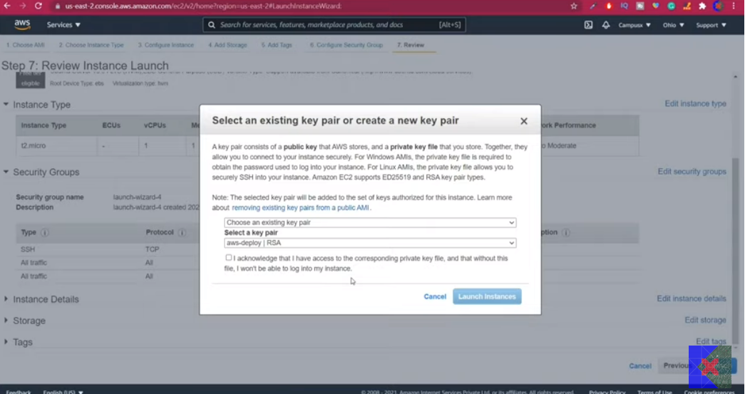

Once click on create window this will open

In future you need to upload files to ce2 instance and also you need to install dependencies in ubuntu

We need to have password: like key pair type

Create new key- it generate new pass word

Click on download

.pem extension

Now create ec2

Download install Putty and winscp

Putty – for install dependencies

Winscp- to upload files

In ec2 instance

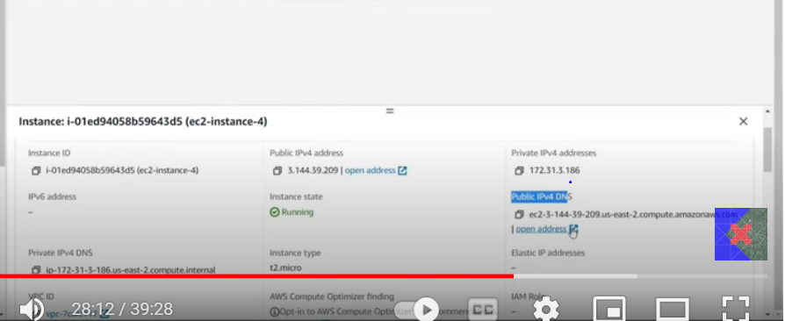

There is PUBLIC IPV4 DNS option

There is address link -open

After uploading files we can see our website

Now go open winscp

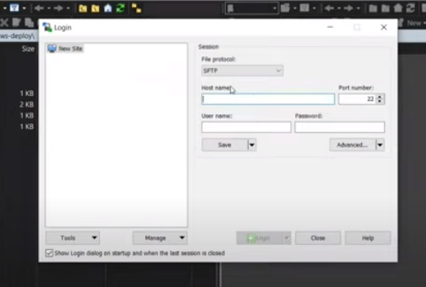

First give hostname

We need to provide credentials

Go to EC2 –

Select instance

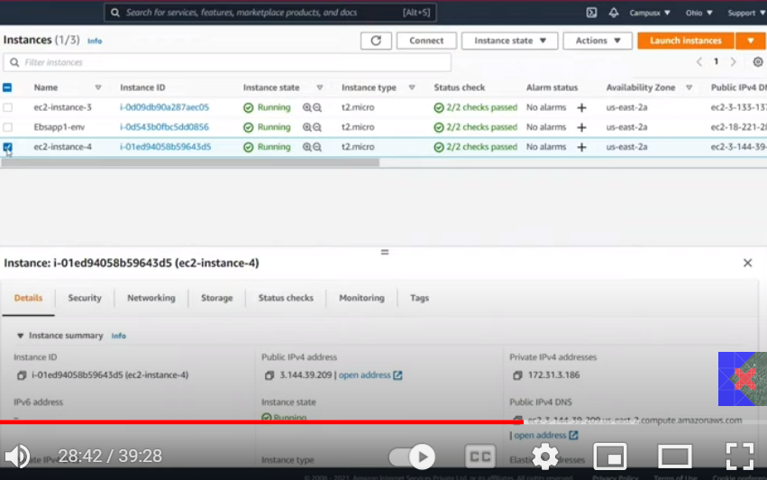

Click on connect

Select host name

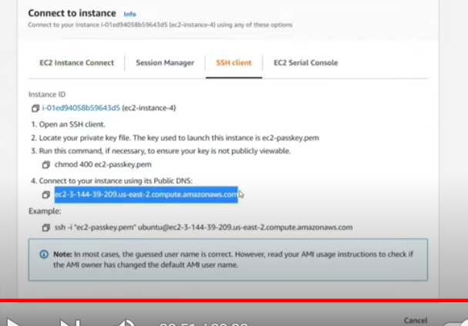

For user name click on ec2 instance connect

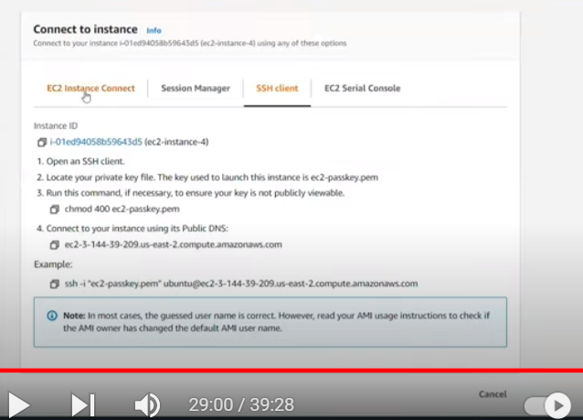

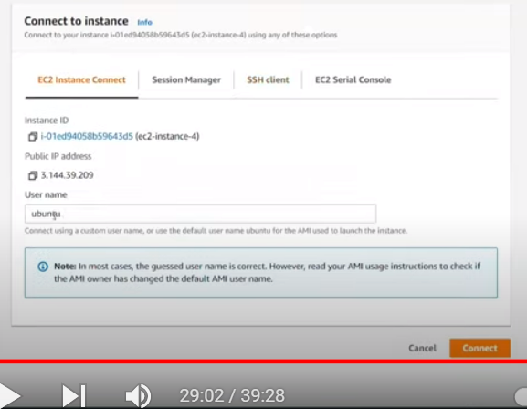

For password

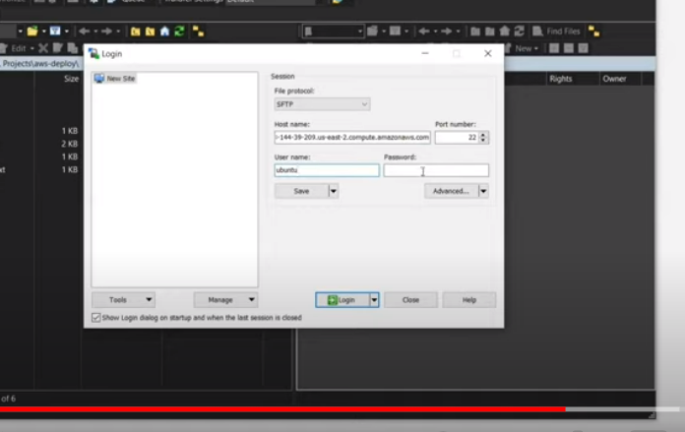

Go to advance

Ssh-authentication

Here we need to provide private key

But we have format .pem

But here we need ppk format

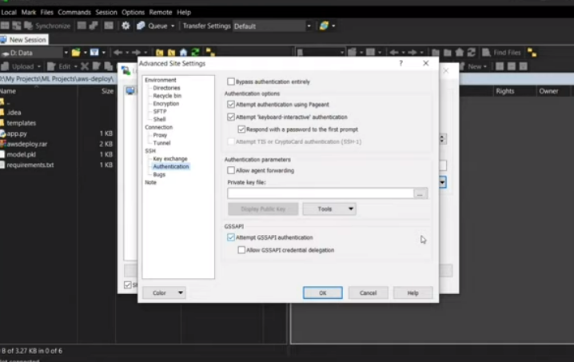

It automatically edits- make it as putty format

Ok-ok-login

.pem file

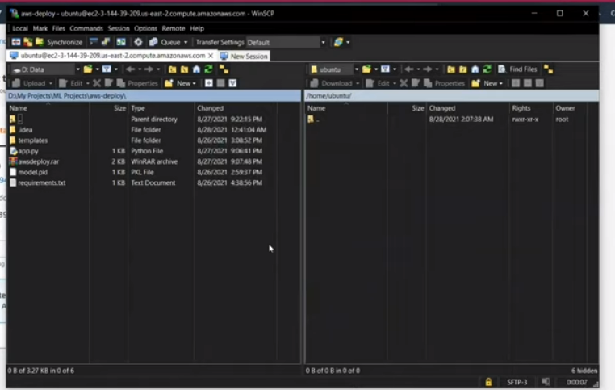

Left oursys

Right ubuntu

In leftside go to ur project dir

Upload these files to ubutu

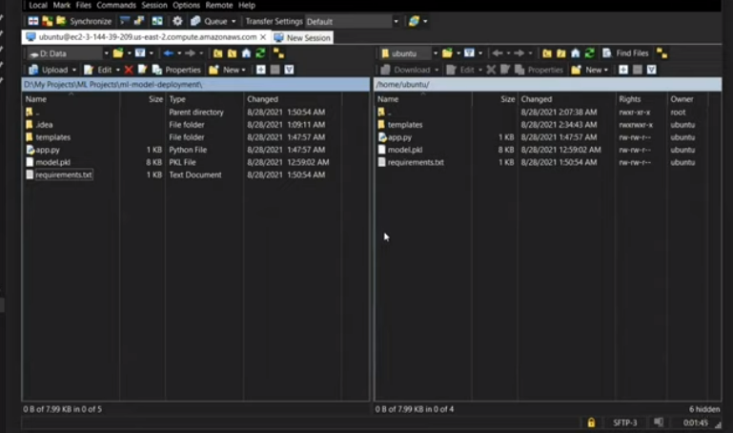

Now in ubuntu server we need to upload dependencies

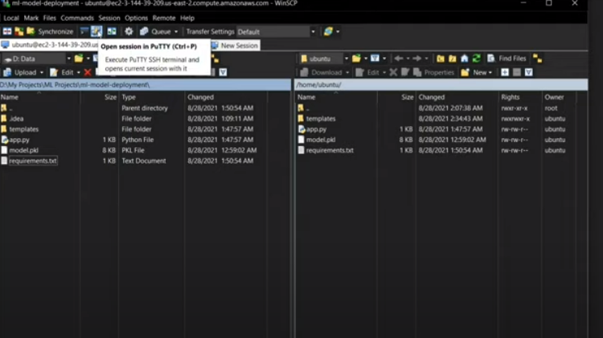

We can directly access putty from this window in icon

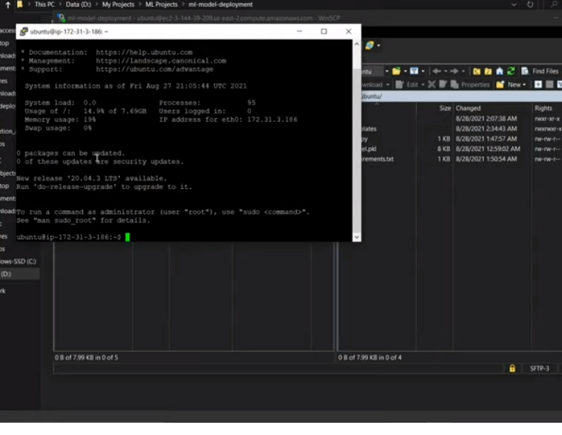

When open kutty it opend ubuntu cmd

From there we need to install libraries

Pip install req.txt

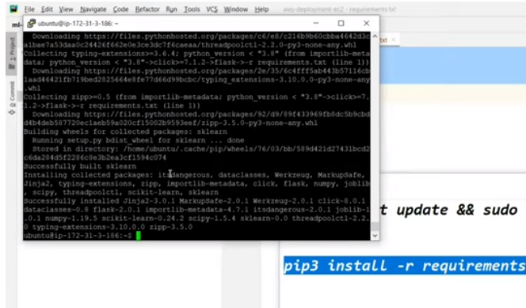

In app.py

We need to give

